Instruction complete all questions in 2 hr.
- Write the Boolean expression for XOR and XNOR gate. Construct the circuit using AOI gates and also construct the Truth table for both of the gates.
- Obtain the logic functions of all logic gates (AOI) using NAND and NOR gates.
- Write the Boolean expression for DE Morgan’s laws and verify them using truth table.
- Write the Boolean expression for distributive law (both AND form and OR form) and verify the law using truth table.
- Study the following circuit diagram and answer the questions given below.
  - Write the Boolean output functions for S and C.
  - Draw the truth table for output S and C.
  - Draw the circuit using AOI.
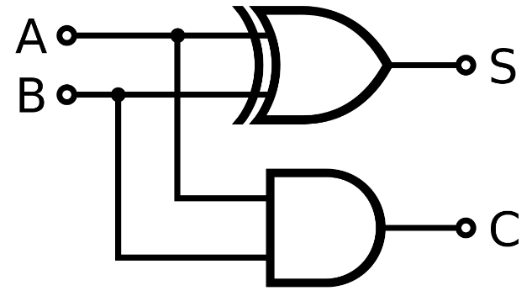
- Simplify the Boolean expression F=AB+A(B+C)+B(B+C) and draw the circuit diagram for the simplified expression.
- If A=1,B=1,C=0,D=1,E=0,G=1,calculate
  - F=A∙B∙C
  - F=C∙A∙B
  - F=!A+B+C
  - F=A∙B+C
  - F=A+B∙C
  - F=A.B+(C+A).D+E+G

- Write the Boolean output function for the following logic circuits.

